How to get to the Royal Brussels Cricket Club
The Brussels British Community Association (BBCA)’s annual mid-summer garden party is being held on Sunday 25 June from 1pm at the Royal Brussels Cricket Club (RBCC) near Lasne-Ohain. The address of the RBCC is:
Royal Brussels Cricket Club
Chemin des Messes 39
1380 Lasne-Ohain
MCWX+QM Lasne <<< Google Plus Code
Unfortunately, public transport on a Sunday around Lasne is virtually non-existent with no TEC bus services running. The nearest rail stations are to the west Waterloo and Braine-l’Alleud (S1) and to the east Genval and Rixensart (S8).
If using GPS/ SatNav it is best to input “Route des Marnières 1, 1380 Ohain (Lasne)” as a waypoint or “via” address with the RBCC address as final destination, which will bring you in to the venue from the right direction.
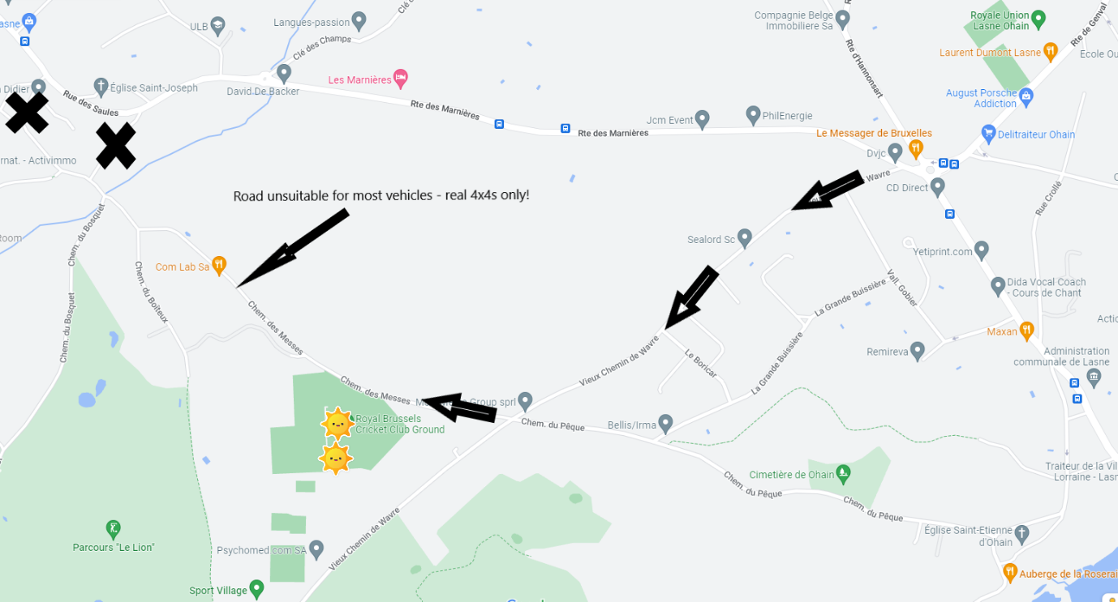
Above is an overview of the RBCC location. It is best approached from the direction of the ‘Le Messager de Bruxelles’ roundabout on the N271. If coming from the Waterloo area GPS often suggests approaching via le Rue de Mont Lassy and le Chemin des Messes. This is not advised! Continue on Route des Marnieres towards Le Messager de Bruxelles restaurant.
A more detailed map of the road layout around the roundabout is shown below.
If you are approaching from Waterloo along the Route des Marnieres you will need to make a sharp right turn into the Vieux Chemin de Wavre just before the restaurant (see photos below).
If you are coming from La Hulpe, Genval or Lasne you must go round the roundabout and take the road towards Waterloo/ Mont-St-Jean (Route des Marnieres) and then almost immediately turn left into Vieux Chemin de Wavre (see photo below).
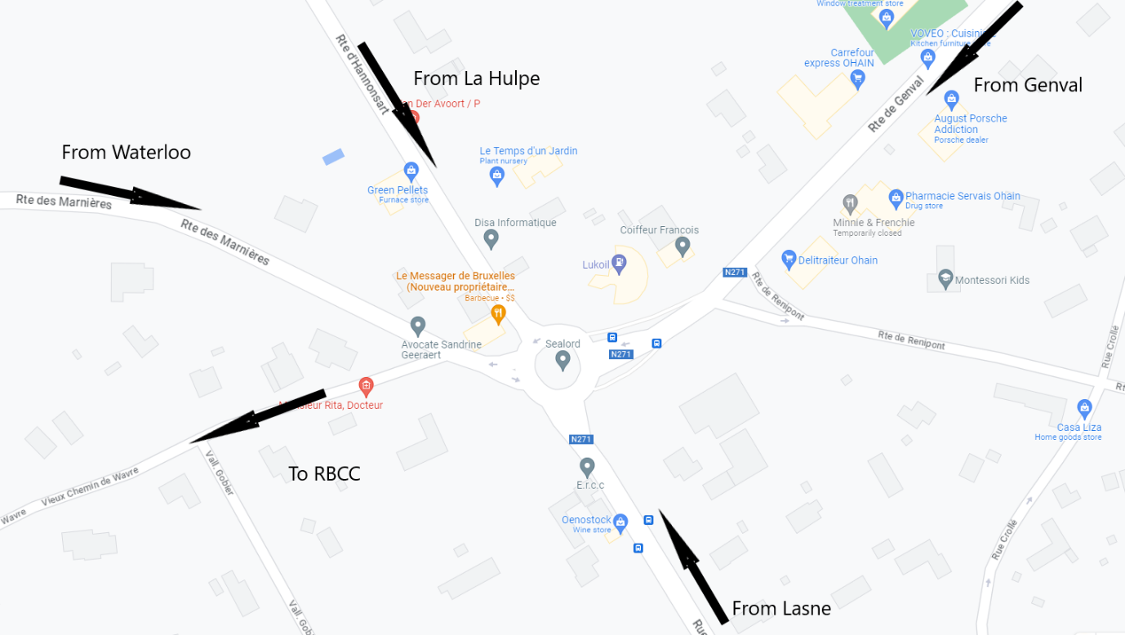
A view of the right turn when approaching from Waterloo is shown below.
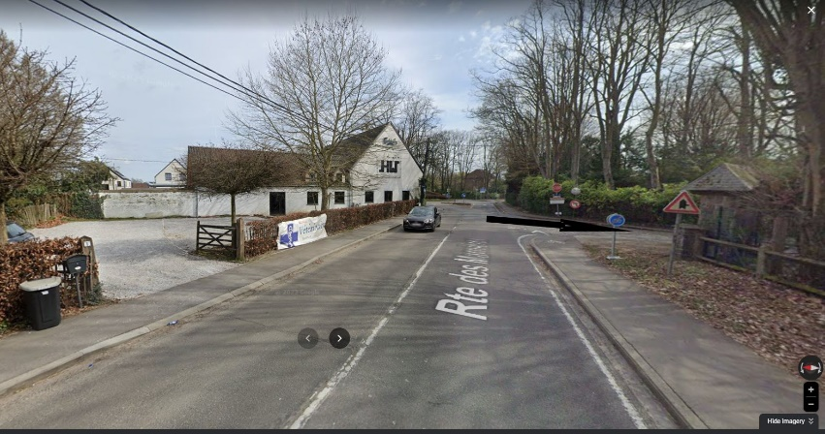
And a view of the left turn when approaching from the roundabout is shown below.
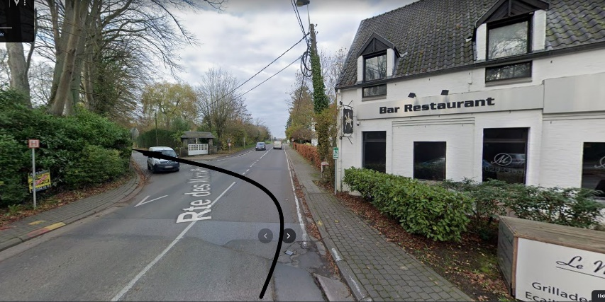
At the entrance to Vieux Chemin de Wavre there are signposts for RBCC, Sport Village and Royal Waterloo Golf Club, but these are only clearly visible if coming from the Waterloo direction.
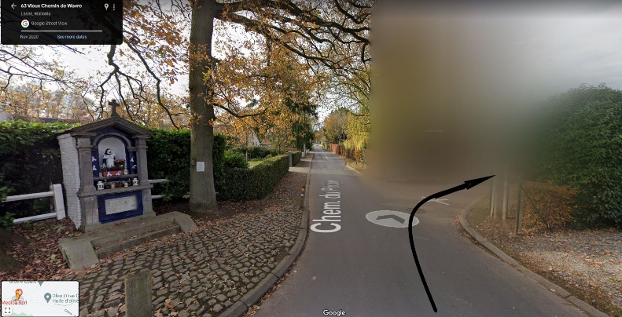
Continue along the Vieux Chemin de Wavre for almost 1 km until you come to a crossroads with a shrine (see photo above). Here turn right into Chemin des Messes.
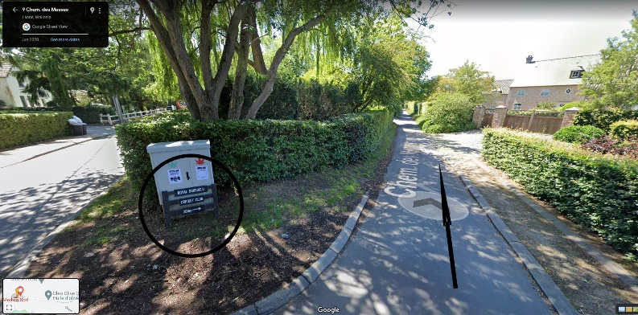
There is a sign for RBCC at the crossroads. If you miss the turn, you will eventually get to the Royal Waterloo Golf Club – turn around and come back!
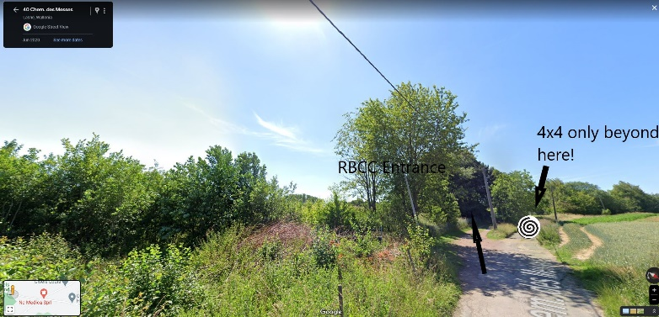
Continue down Chemin des Messes (in parts a not-so-well-made and rather slim road) for ~350 metres and the entrance to RBCC will be on your left, as open fields appear on your right.
Ample car parking will be available at RBCC.
BBCA Midsummer Garden Party

